Software Requirements Specification (SRS)
on
Student Performance Management System (SPMS)
by
1. Vishwadeep Vishwanth Sankpal
2. Prafull Prataprao Shinde
3. Varad Mahadev Kadam
4. Swapnil Dilip Pol

1. Introduction
1.1 Purpose
The purpose of this document is to define the functional and non-functional requirements of the Student Performance Management System (SPMS).
This SRS serves as a reference for developers, testers, faculty, and evaluators to understand system behavior, constraints, and expectations.
1.2 Scope
The Student Performance Management System is a centralized academic system designed to:
- Manage student performance records
- Automate marks entry and evaluation
- Generate course-wise and subject-wise reports
- Provide transparent access to performance data for students, staff, and administrators
The system supports three user roles:
- Admin
- Staff
- Student
1.3 Intended Audience
- Software Developers
- Project Evaluators
- Faculty Members
- Students
- System Administrators
2. Overall Description
2.1 Product Perspective
SPMS is a web-based academic management system that replaces traditional manual record-keeping.
It maintains structured data related to courses, subjects, students, faculty assignments, and performance metrics.
2.2 Product Functions (High-Level)
- Secure role-based authentication
- Course and subject management
- Marks entry and evaluation
- Automated performance card generation
- Rank calculation
- Report generation
2.3 Operating Environment
- Web Browser (Chrome, Edge, Firefox)
- Server-side application
- Database Management System
- Internet/Intranet based access
2.4 User Classes and Characteristics
User | Description
Admin | Full system control and configuration
Staff | Academic operations and marks entry
Student | View and update personal academic data

2.5 Design and Implementation Constraints
- Role-based access control is mandatory
- Data integrity must be preserved
- Marks once finalized should not be modified without authorization
- Secure authentication required
3. Functional Requirements
3.1 Admin Requirements
- Admin shall be able to log in securely.
- Admin shall view student details.
- Admin shall view student performance cards.
- Admin shall add, edit, and update courses.
- Admin shall add, edit, and update subjects.
- Admin shall define and edit subject passing criteria.
- Admin shall assign tasks to Staff.
- Admin shall assign groups of students to faculty.
- Admin shall view course-wise performance reports.
- Admin shall view subject-wise performance reports.
3.2 Staff (Faculty) Requirements
- Staff shall log in securely.
- Staff shall view and update profile information (name, email, password).
- Staff shall receive assigned tasks.
- Staff shall enter marks for Theory, Lab, Internal of each subject.
- Staff shall view task status.
3.3 Student Requirements
- Student shall log in securely.
- Student shall update profile details (name, email, mobile number).
- Student shall view the performance card, including marks theory, lab & internal of each subject with passing status and his/her Rank.
4. Non-Functional Requirements
- Student shall get an email after enrolling on a course that consists of a password and PRN automatically
4.1 Reliability Requirements
- Data consistency must be maintained
- System should recover gracefully from failures

5. System Models
5.1 Use Case Diagram
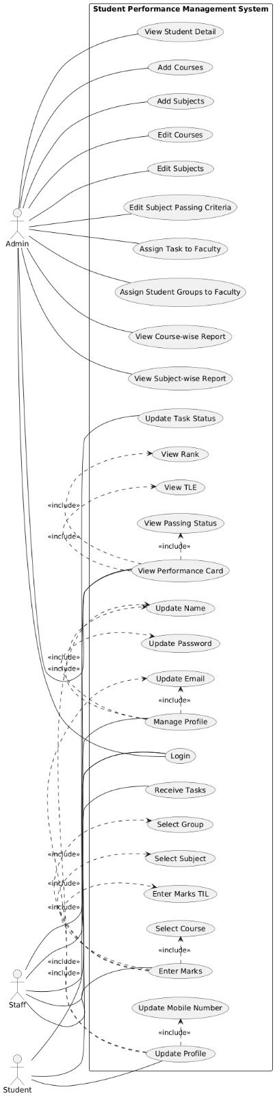
5.2 ER Diagram

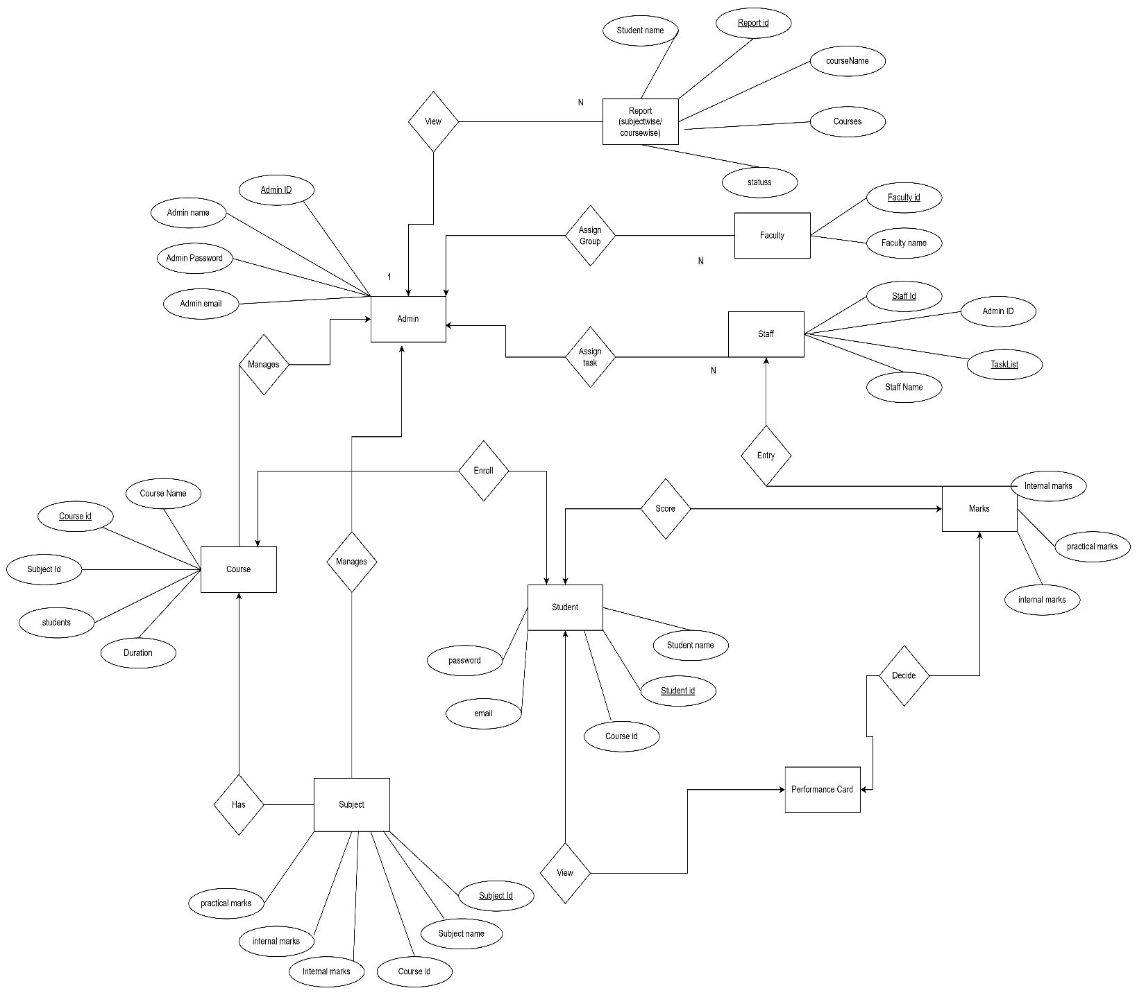

6. Technology Stack
6.1 Frontend Technologies
- Razor Pages
  - Server-side page rendering
  - Clean separation of UI and logic
  - Tight integration with ASP.NET Core
- HTML5, CSS3
  - Page structure and styling
- Bootstrap
  - Responsive and consistent UI
6.2 Backend Technologies
1. ASP.NET Core
  - High-performance, cross-platform framework
  - MVC-based architecture
  - Secure authentication and authorization
2. C#
  - Strongly typed language
  - Business logic and data processing
6.3 Database (Mention as per your use)
1. SQL Server / SQL Server Express
  - Relational database for structured academic data
  - ACID-compliant transactions
6.4 Version Control System
1. GitHub
  - Source code versioning
  - Collaboration and change tracking
  - Backup and project history

7. Future Enhancements
- Graphical analytics dashboard
- Export reports (PDF/Excel)
- Mobile application support
8. Conclusion
The Student Performance Management System aims to digitize and standardize academic performance tracking.
This SRS provides a clear and structured foundation for design, development, and evaluation.

UI
https://drive.google.com/file/d/1FdPGtD-bZm_eG0wbErYuhpDOV7RGitUt/view?usp=sharing

